Anti-spoofing is not enabled on outside interface of Palo Alto Internet Firewall

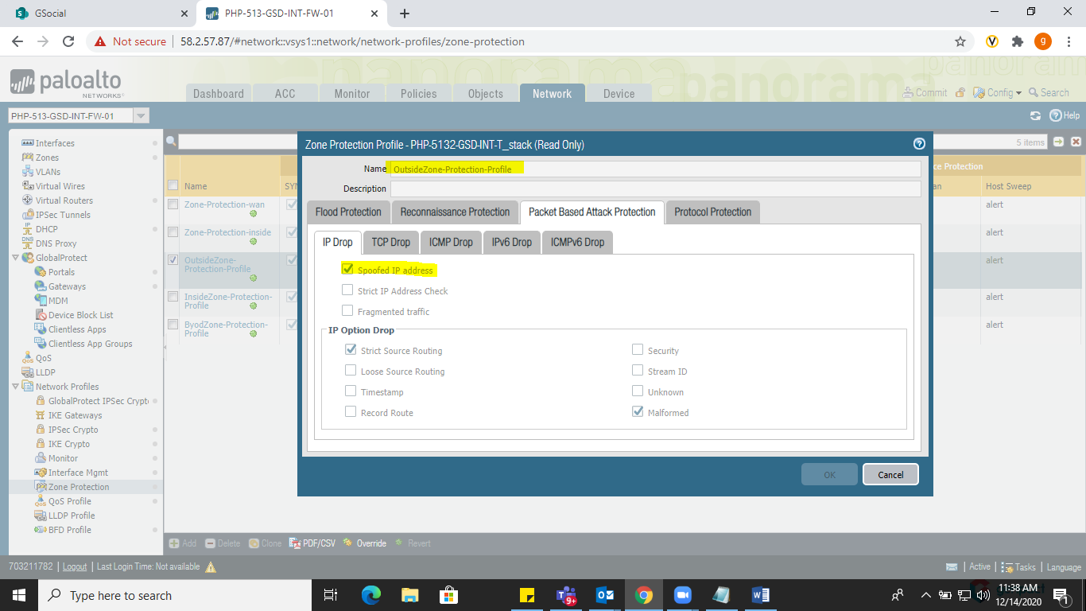

Account Lockout Duration is set to 0 minutes on Palo Alto Internet Firewall (5132 & ETON) which should be at least 30 minutes as per PCI Req 8.1.7

